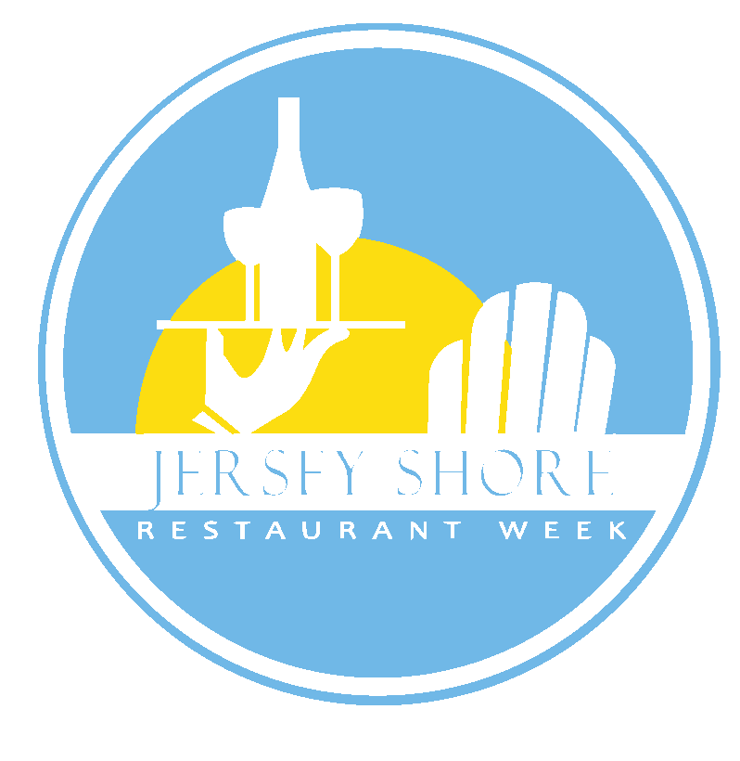
Jersey Shore Restaurant Week April 13-22, 2018
The objectives of Restaurant Week are to boost business for restaurants during traditionally slow times of year (April and November) and to encourage consumers to dine out more often and try new restaurants. Three (3) course meal prices have been designed to accommodate both casual pub style restaurants and fine dining restaurants and to provide real value for the consumer.
RESTAURANT REQUIREMENTS
1. Participants are required to offer a three (3) course meal with three (3)
appetizer, three (3) entree and three (3) dessert choices every night during
Restaurant Week for either $22.18 or $32.18. Lunch option must offer three
(3) entree choices and one (1) of the following: appetizer, salad, dessert, glass
of beer/wine for $15.18 or less. Failure to offer three choices in each
category for dinner will result in menu rejection.
2. All restaurants are required to post the JSRW logo on their site. We will forward
you a copy of the logo upon receipt of your participation fee. Failure to post the
logo may result in cancellation of participation with no refund.
3. Please note
MENUS
1. Menus must be submitted no later than March 16, 2018 for timely posting
on the JSRW site. If you miss this date, please don't contact us asking when
your menu will get up. Menus will be posted in the order in which they are
received, and as time allows. Remember over 90% of consumers told us they
looked at the menus on our site before deciding where to go.
2. Send menus to Jennifer@jerseyshorerestaurantweek.com to avoid delays.
3. Participants are free to offer supplemental items on their Restaurant Week menu,
but only after the three choices in each category have been met. For example, a
4th entree could be offered, perhaps a strip steak, with a supplemental cost, but
only if there are three choices offered under the established price guidelines.
4. You can restrict your menu on Friday and Saturday nights. If plan to do so, you
must advise us of the restriction when you submit your menu so that we
may include this information on our website, and you must tell customers when
they are making a reservation. Consumers do not like this restriction, but we
understand the need for you to do it. Problems can be mitigated by the
following:
a. make sure we know you want to restrict the menu.
b. be sure your reservationists communicate the restriction.
c. consider expanding your weekend hours and possibly offering the menu from
4:00pm to 6:45pm to accommodate more people.
We are implementing new language for the restriction that should be helpful to you:
“To receive the Restaurant Week menu on Friday and Saturday nights, your complete party must be seated by 6:45pm. That means your reservation must be for 6:45pm or earlier. We are sorry but there can be no exceptions to this policy.”
ADVERTISING/PROMOTION
1. Jersey Shore Restaurant Week Web Site (www.jerseyshorerestaurantweek.com)
60,000+ unique visitors, 500,000+ page views
2. Asbury Park Press color insert with all participating restaurants to 50,000 homes
3. Full page ad in the Tri-City news with all participating restaurants
4. Posters, table tents and bill stuffers for in-house marketing
5. Facebook posts
6. JSRW weekly emails - 90,000 people
7. Extensive Facebook advertising
COST OF PARTICIPATION
1. Dinner or Lunch and Dinner - $350 full service restaurants, $225 BYOB
Restaurants.
2. Lunch Only - $250 full service restaurants, $175 BYOB Restaurants
The fee includes posters, table tents, bill stuffers, inclusion in print ads, placement on the JSRW web site, menu posting on the site and Special Events promotion.
Companies with more than one restaurant with different names are required to pay a restaurant fee for each restaurant. The first restaurant will be regular price - additional restaurants from the same company will be charged $275 for full service restaurants and $175 for BYOB's.
SIGN-UP
Participation Invoice
Deadline for April 2018 Restaurant Week Sign-Up is FEBRUARY 1, 2018. Signups after February 1st will incur a $75 late fee. Sign-ups after February 15th will incur a $100 late fee.
COST (Check One)
___ Full Service Restaurant - $350
___ BYOB Restaurant - $225
___ LUNCH ONLY – Full Service - $250
___ LUNCH ONLY – BYOB - $175
CONTACT INFORMATION:
Restaurant Name: ___________________________________________________
Contact Name: _____________________________________________________
Contact Cell Phone #: ________________________________________________
Contact Email Address: _______________________________________________
SIGN-UP
On-line at www.jerseyshorerestaurantweek.com
OR Mail to: JSRW
Box 352
Brielle, NJ 08730

