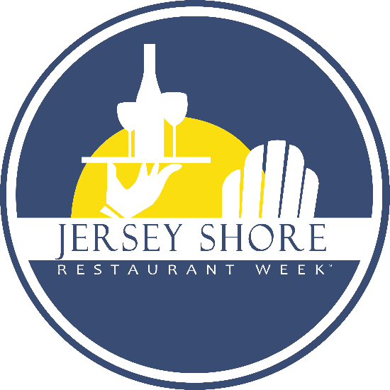
November 5-November 14, 2021
OVERVIEW
- Our website gets over 60,000 unique visitors and over 500,000 page views in the weeks before the event – 90%+ of consumers visit our website to view participant menus
- Google Analytics indicates that 22% of Jersey Shore Restaurant Week website visitors come from outside New Jersey – new customers!
SIGN-UP
The sign-up deadline is September 1, 2021. We will remind you every two weeks until that date. You are not considered “signed-up” until we receive your participation fee. Restaurants who sign-up after February 15th will be subject to late fees, which we will enforce.
MENUS
- Menus are due October 1, 2021
- Please send your menu to jennifer@jerseyshorerestaurantweek.com to avoid delays in having it posted
- You must tell us when you submit your menu if you are restricting it to serve until 7pm only on Friday and/or Saturday nights
- Please do not submit your menu without the minimum required three (3) choices in each course category – appetizer, entrée and dessert – it will not be posted until it meets our minimum requiremen
Jersey Shore Restaurant WeekTM – November 5-14, 2021
The objectives of Jersey Shore Restaurant WeekTM are to boost business for restaurants during traditionally slow times of year (April and November) and to encourage consumers to dine out more often and try new restaurants. Three (3) course meal prices have been designed to accommodate both casual pub-style restaurants and fine dining restaurants, while providing real value for the consumer.
RESTAURANT REQUIREMENTS
Participants are required to offer the following every day of Restaurant Week:
BREAKFAST
Breakfast option must offer (3) entrée choices and at least (2) of the following: juice, coffee/tea, home fries/hash browns, or toast – for $11.21 or less
LUNCH
Lunch option must offer (3) entrée choices and at least (1) of the following: appetizer, salad, dessert, glass of beer or wine – for $15.21 or less
DINNER
Dinner option must offer a three (3) course meal with a minimum of (3) appetizer, (3) entrée and (3) dessert choices every night during the 10-day Restaurant Week period for either $23.21 or $33.21
Failure to offer the proper choices on your menu will result in menu rejection!
All participating restaurants are required to post the JSRW logo on their website. Failure to post the logo may result in cancellation of participation with no refund.
MENUS
- Menus must be submitted no later than October 1, 2021 for timely posting on the JSRW website - menus received after March 14th will be posted as time allows and in the order they are received
- Send your menu directly to Jennifer – jennifer@jerseyshorerestaurantweek.com – to avoid posting delays
- Participants are free to offer supplemental items on their JSRW menu, but only after the minimum choice requirement has been met – for example, a 4th entrée could be offered with a supplemental cost, but only if there are three entrée choices offered under the established price guidelines
- For dinner, you can restrict your menu on Friday and/or Saturday nights to serve until 7pm only. If you plan to do so, you must advise us of the restriction when you submit your menu so that we may include this information on our website and you must tell customers when they are making a reservation. Consumers do not like this restriction, but we understand the need for it. Problems can be mitigated by the following:
  - Make sure we know you want to restrict the menu
  - Be sure your reservationists communicate the restriction
  - Consider expanding your weekend hours and possibly offering the menu from 4:00-6:45pm to accommodate more people
COST OF PARTICIPATION – From only $17.50 per day
$175 – Breakfast and/or Lunch ONLY – BYOB
$250 – Breakfast and/or Lunch ONLY – Full Service
$250 – Lunch and/or Dinner – BYOB
$350 – Lunch and/or Dinner – Full Service

The participation fee includes posters, hostess stand easel, bill stuffers, inclusion in print ads, placement on the JSRW website, menu posting on the website and Special Event promotion. Companies with more than one restaurant with different names are required to pay a participation fee for each restaurant. The first restaurant will be at the regular price – additional restaurants from the same company will be charged $275 for full service restaurants and $175 for BYOB’s.

Jersey Shore Restaurant WeekTM Participation Invoice

Sign-up deadline for November 2021 Jersey Shore Restaurant WeekTM is September 1, 2021. Restaurants are noted considered to be “signed-up” until the participation fee has been received by JSRW. Sign-ups after September 1st will incur a $75 late fee; after March 15th, a $100 late fee.

COST (check one)
____ $175 – Breakfast and/or Lunch ONLY – BYOB
____ $250 – Breakfast and/or Lunch ONLY – Full Service
____ $250 – Lunch and/or Dinner – BYOB
____ $350 – Lunch and/or Dinner – Full Service

CONTACT INFORMATION:
Restaurant Name: ________________________________________________________________________

Restaurant Address: ________________________________________________________________________

Restaurant Phone Number: ________________________________________________________________________

Restaurant Website: ________________________________________________________________________

Contact Name: ________________________________________________________________________

Contact Cell Phone: ________________________________________________________________________

Contact Email Address: ________________________________________________________________________

SIGN-UP
Online at www.jerseyshorerestaurantweek.com
- OR –
Mail to: JSRW
Box 352
Brielle, NJ 08730
QUESTIONS?: Contact JSRW Chairman, Jim Flynn, at 732-859-5643 or jim@jerseyshorerestaurantweek.com.

